<SoLove Co.,Ltd.>

**<Work BreakdownStructure>**

**<Student Association Management Sytem>**

Version 1.0

Prepare by

Mr.Sitta Chumklaew 5730213074

Miss.Uraiwan Puakphet 5730213031

Miss.Puttinun Duangsamran 5730213038

Mr.Jasadaporn Sain-Un 5730213073

Mr.Tanawat Meechai 5730213080

Mr.Pasin Sommung 5730213096

21/10/2016

# 1.Revision History

**Revision History identify changes to the Design Document.**

|  |  |  |  |
| --- | --- | --- | --- |
| **Name** | **Date** | **Description** | **Version** |
|  |  |  |  |
|  |  |  |  |

# 1.Use Case Overview

## **Use Case Diagram Level 1: Repairs Management Sub-System (UC100)**

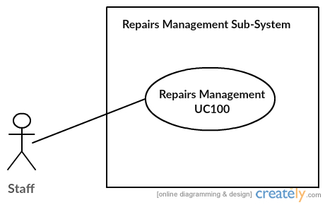

## 

## **Use Case Diagram Level 2: Repairs Management Sub-System (UC100)**

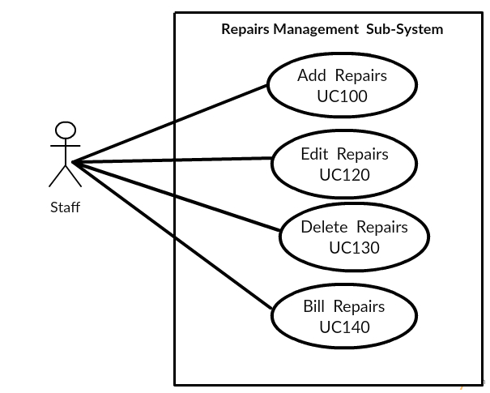

**Use Case Diagram Level 1: Divice’s Management Sub-System (UC200)**

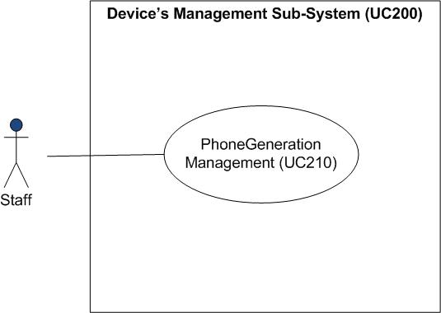

**Use Case Diagram Level 2 : PhoneGeneration Management (UC210)**

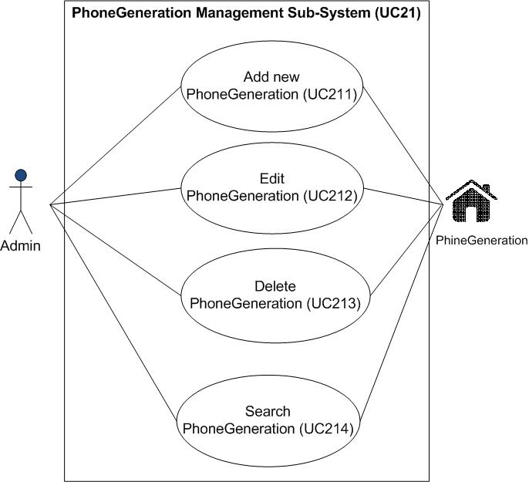

PhoneGeneration

Staff

**Use Case Diagram Level 1: Show Information Sub-System (UC300)**



**Use Case Diagram Level 2 : Phone’s Generation Management (UC300)**



**Use Case Diagram Level 1: Personal’s Management Sub-System (UC400)**

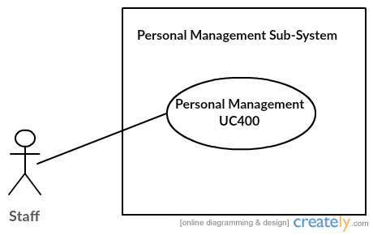

**Use Case Diagram Level 2: Personal’s Management Sub-System (UC400)**

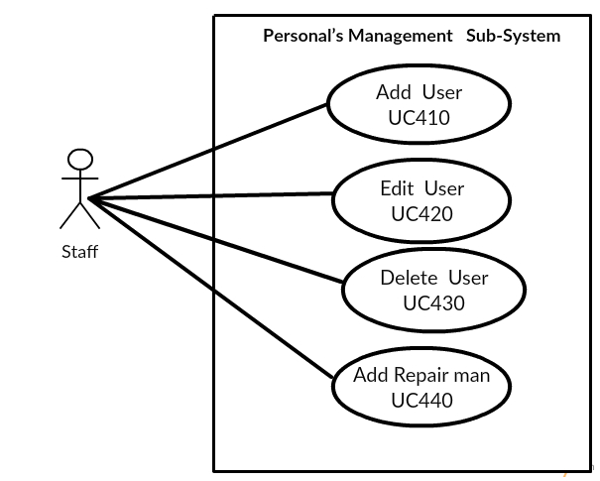

**Use case Diagram LV1: Shop and Bill (UC500)**



**Use case Diagram LV2 : Bill Management (UC510)**



**Use case LV2 : Shop Management (UC520)**



**Use Case Diagram Level 1: Report Sub-System (UC600)**

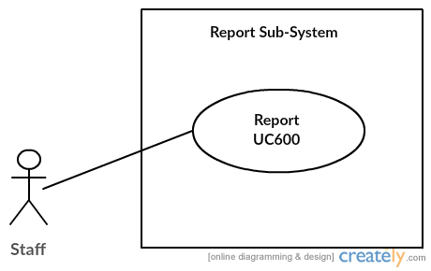

**Use Case Diagram Level 2 : Report Sub-System**

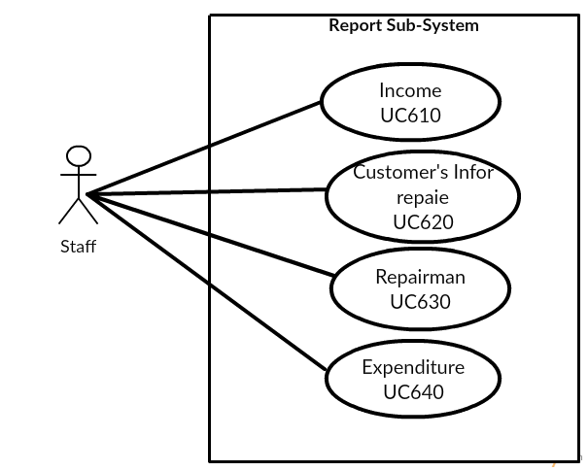

**Class Diagram**



**Model-View-Controller (MVC) Model**

* **Add Repairs**

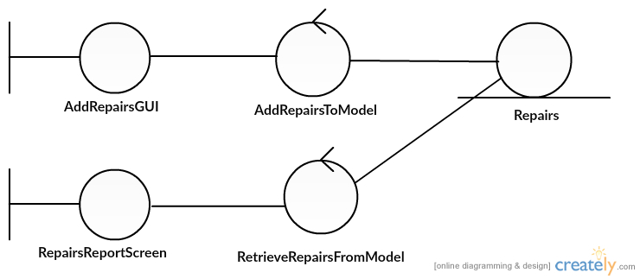

Miss Uraiwan Puekphet 5730213031 SE3

* **Edit Repairs**

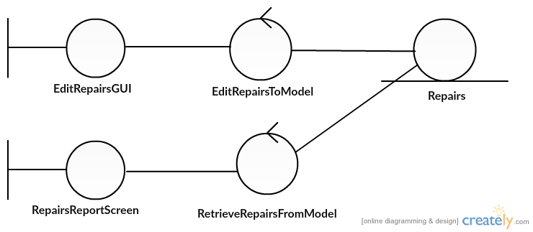

* **Delete Repairs**

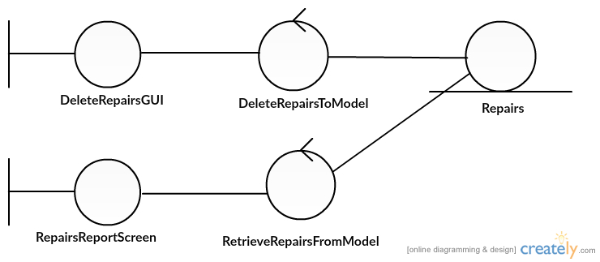

* **Print bill Repairs**

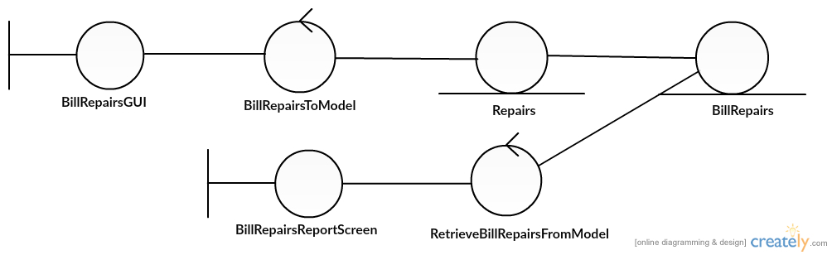

**MVC Add Phone’s Generation**

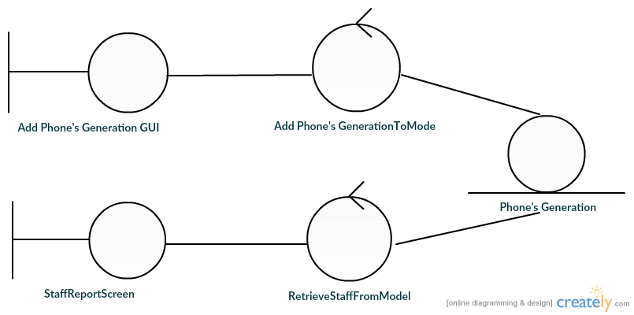

**MVC Edit Phone’s Generation**

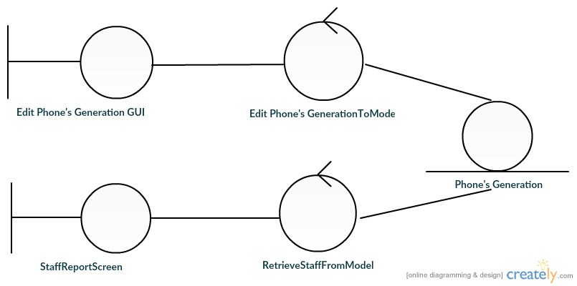

**MVC Delete Phone’s Generation**

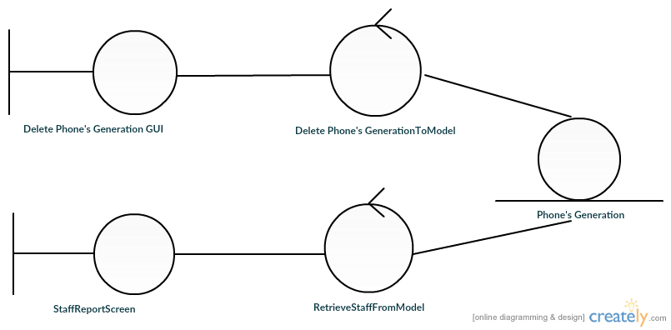

**MVC Search Phone’s Generation**

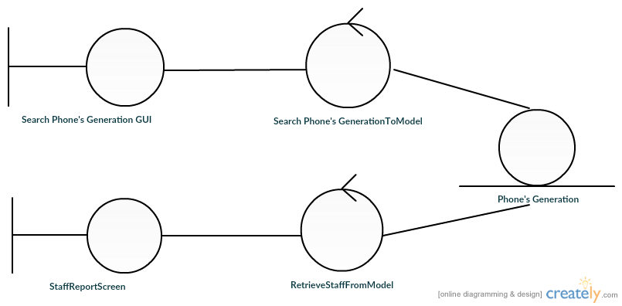











**• Add User**

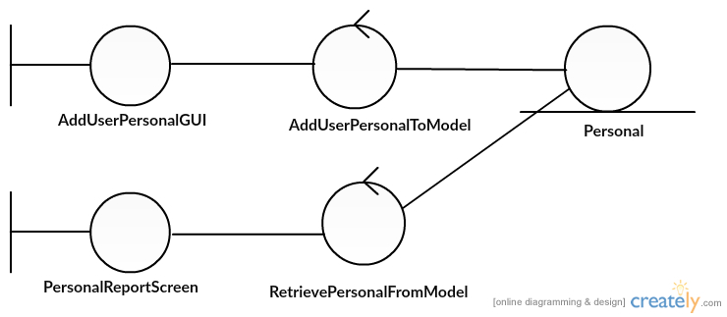

**• Edit User**

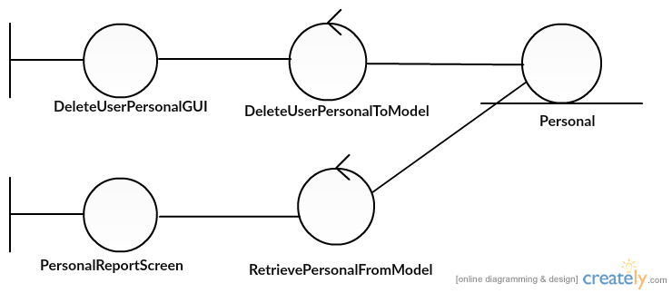

* 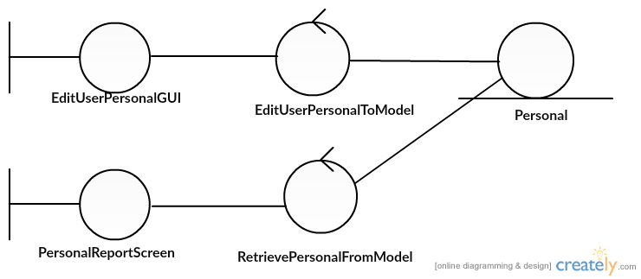**Delete User**
* **Add Repairman**

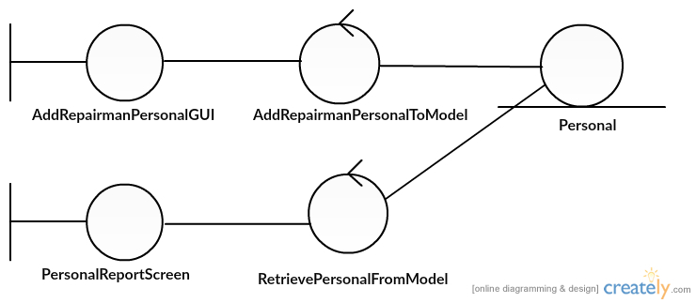

**Bill Management**



**Shop Management**



**Income**

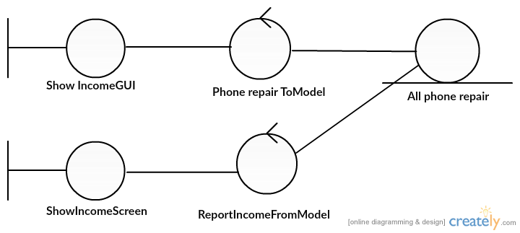

**Customer’s info. As Repair**

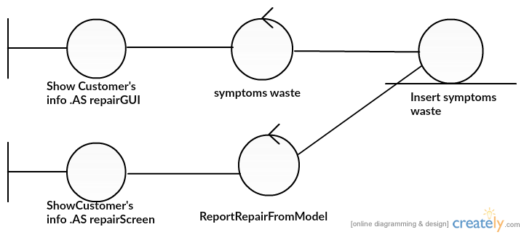

**Repairman**

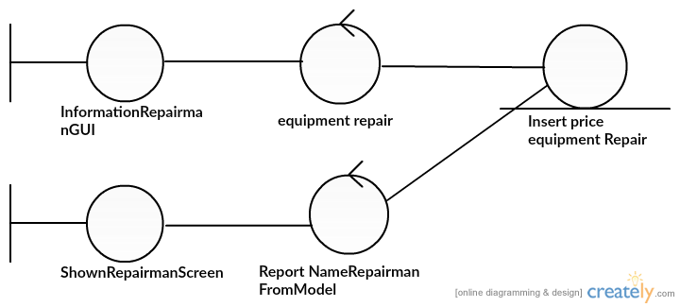

**Expenditure**

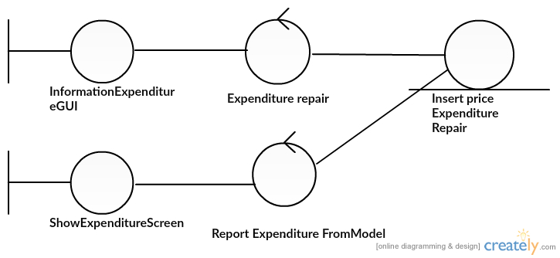

**System Behaviour Model**

**Sequence Diagram demonstrating operation “add, update, delete, bill repairs”**

1. **Repairs**
   1. **Add Repairs**

* This diagram describes the system scenario of “UC110: Add Repairs”

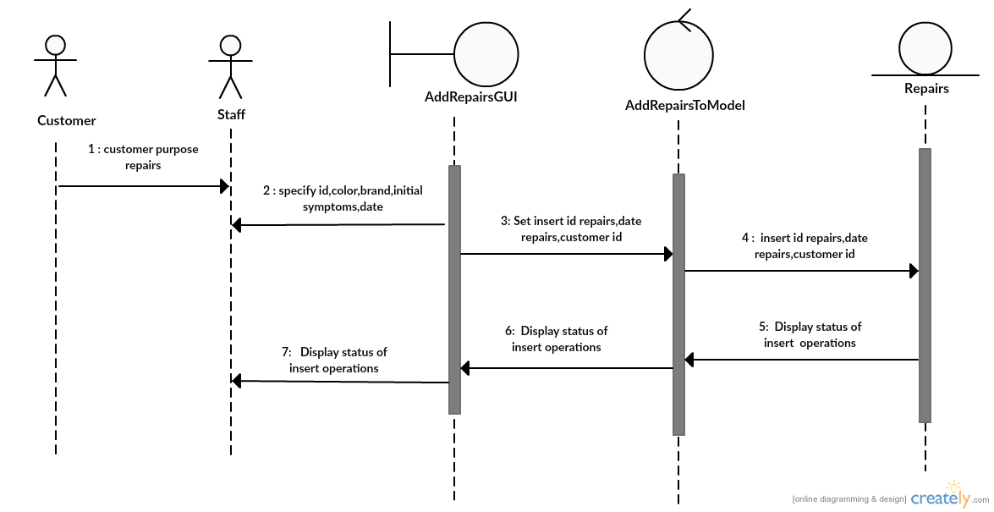

* 1. **Edit Repairs**
* This diagram describes the system scenario of “UC120: Edit Repairs”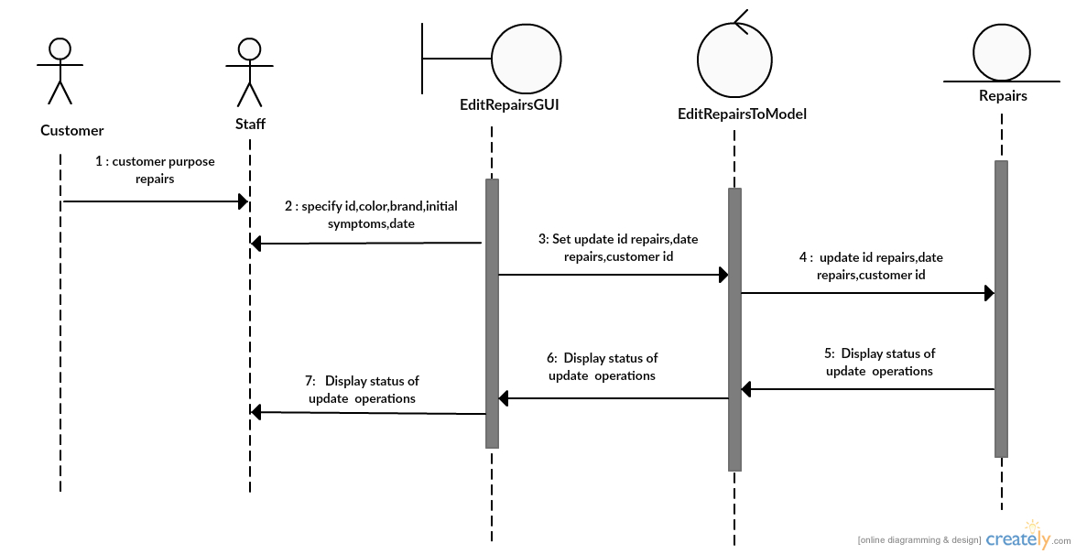
  1. **Delete Repairs**
* This diagram describes the system scenario of “UC130:Delete Repairs”

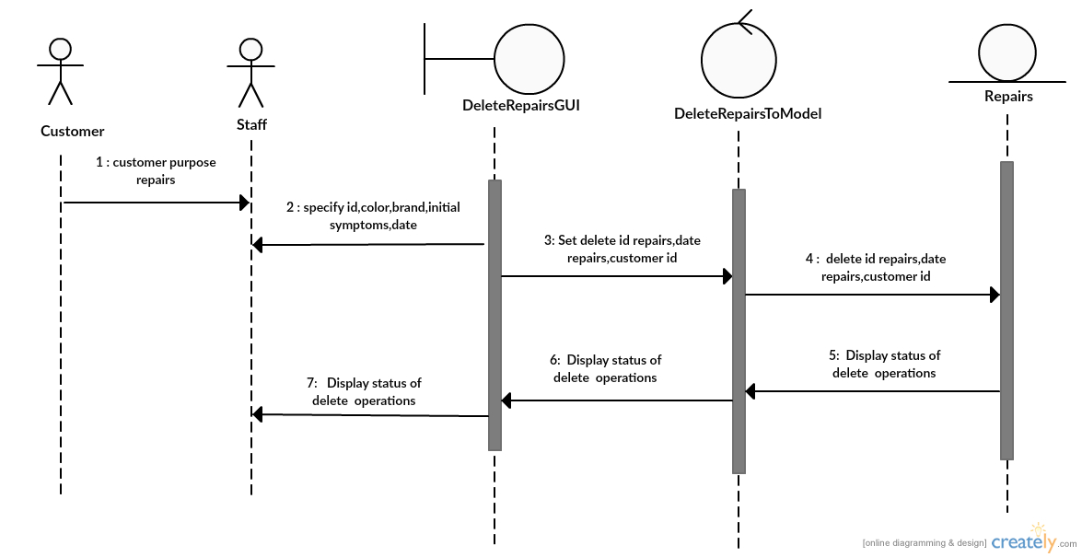

* 1. **Print bill Repairs**
* This diagram describes the system scenario of “UC140:Bill Repairs”

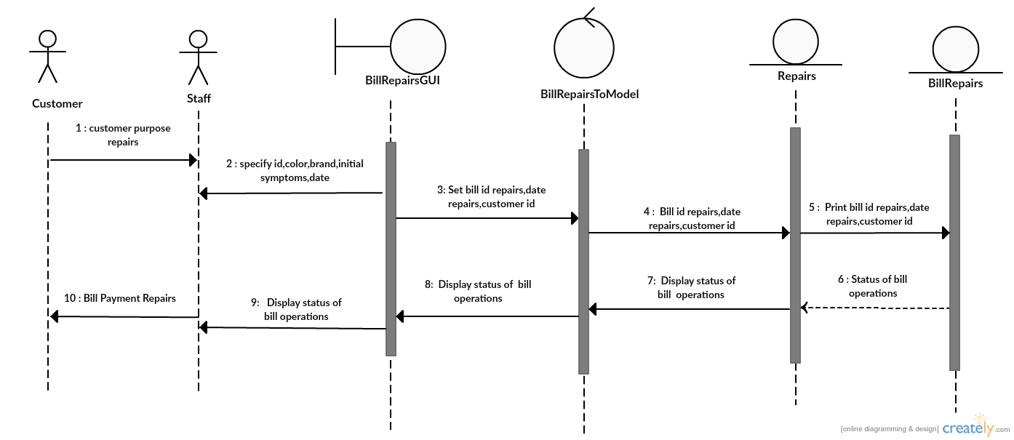

**Sequence Diagram demonstrating operation “add new Phone’s Generation”**

This diagram describes the system scenario of **“UC211: Add new Phone’s Generation”**

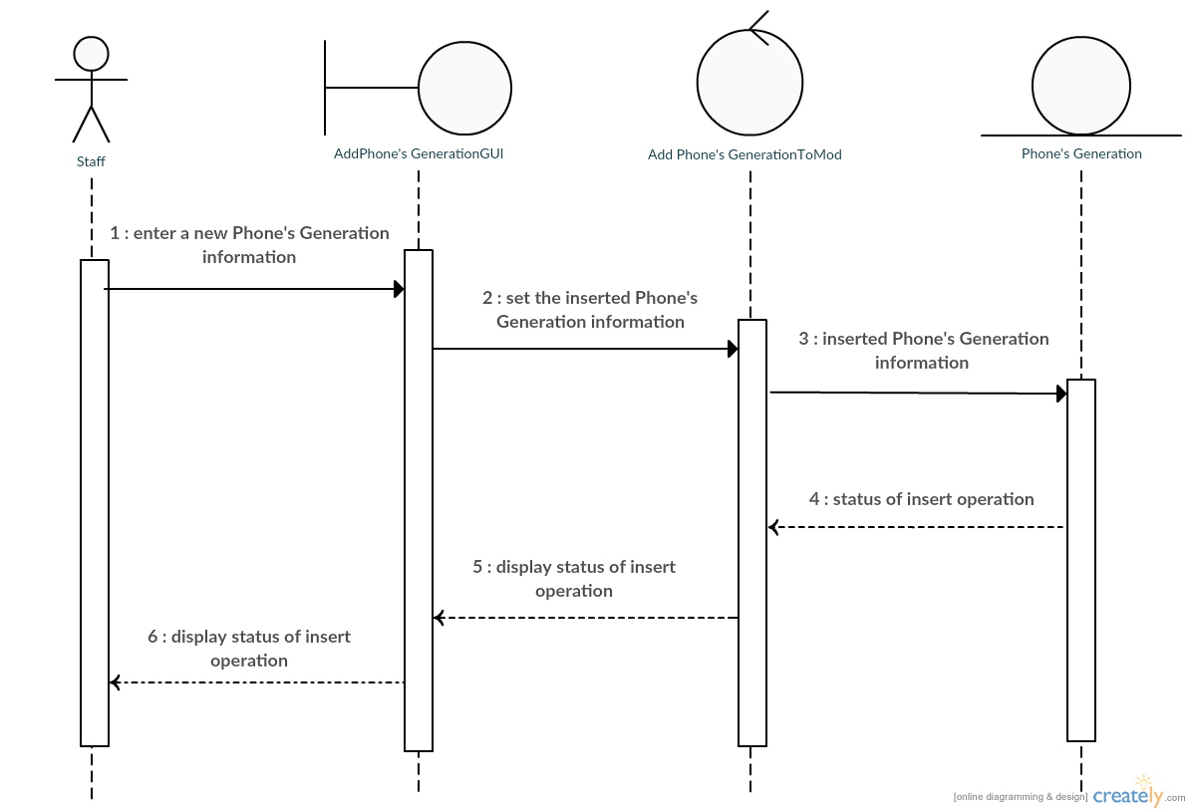

**Sequence Diagram demonstrating operation “update Phone’s Generation”**

This diagram describes the system scenario of **“UC212: Edit Phone’s Generation”**

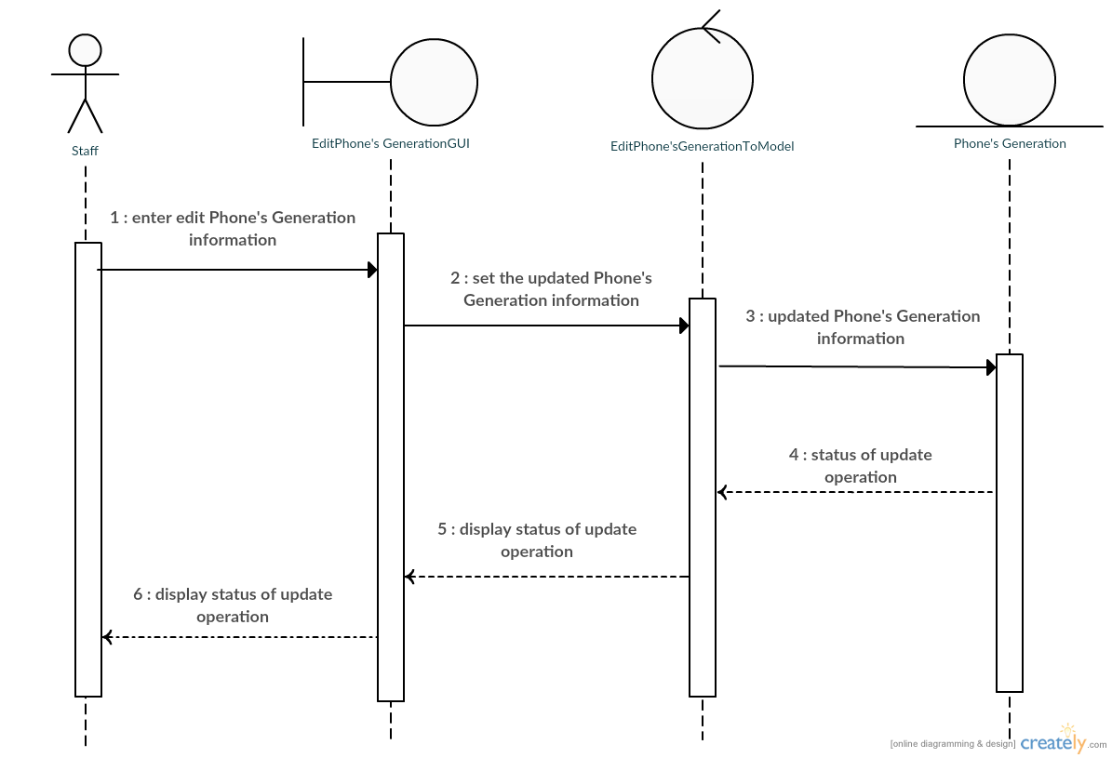

**Sequence Diagram demonstrating operation “delete Phone’s Generation”**

This diagram describes the system scenario of **“UC213: Delete Phone’s Generation”**

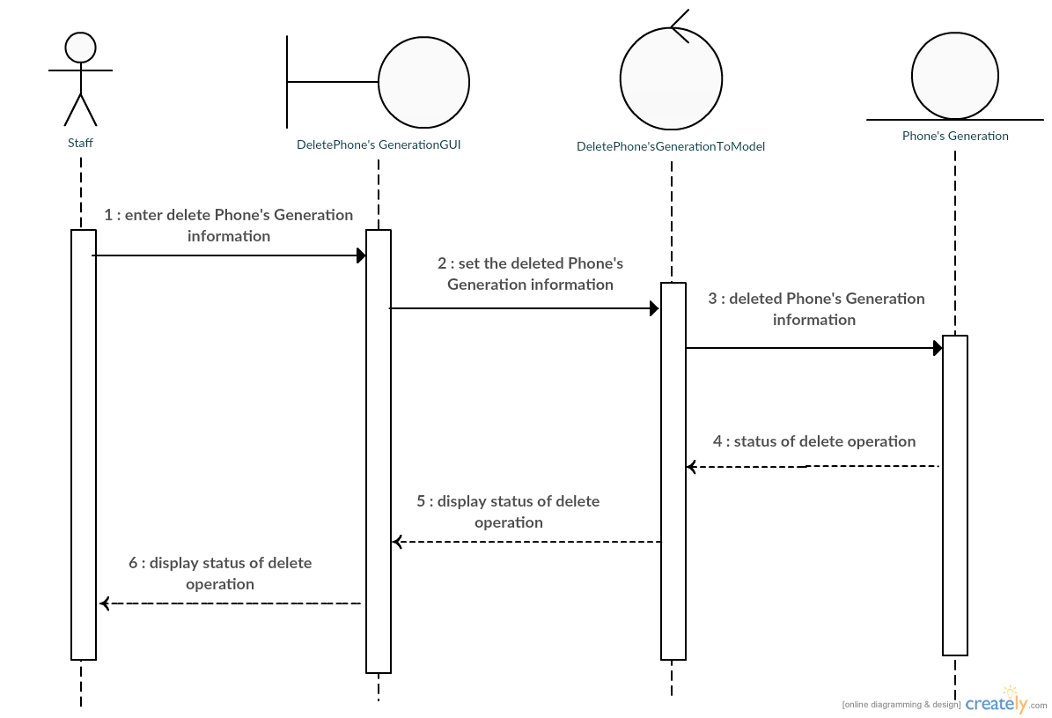

**Sequence Diagram demonstrating operation “search Phone’s Generation”**

This diagram describes the system scenario of **“UC214: Search Phone’s Generation”**

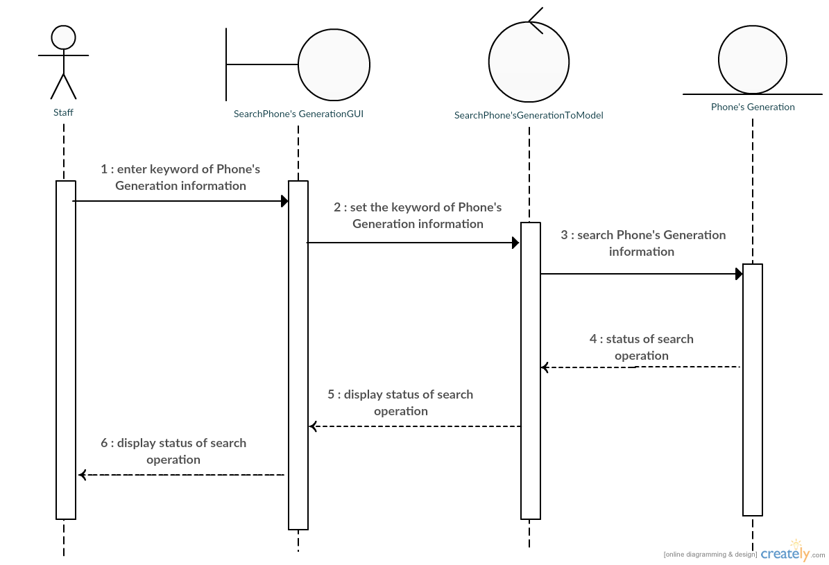

**Sequence Diagram demonstrating operation “show customer take back”**

This diagram describes the system scenario of **“UC310: show customer take back”**

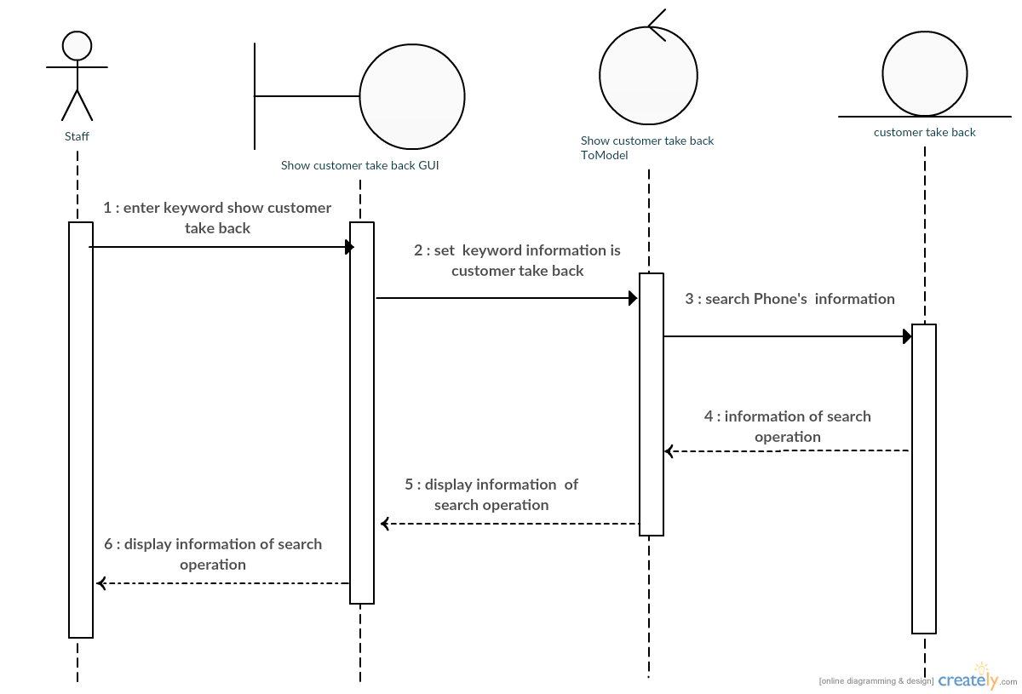

**Sequence Diagram demonstrating operation “turn back to customer”**

This diagram describes the system scenario of **“UC320: turn back to customer”**

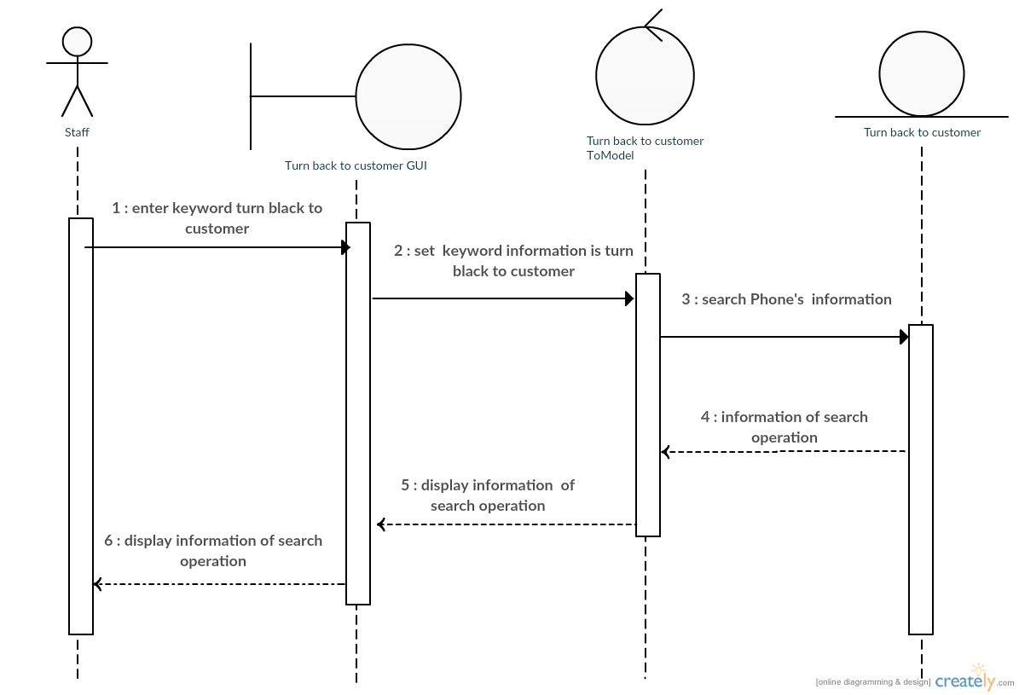

**Sequence Diagram demonstrating operation “waiting for repair”**

This diagram describes the system scenario of **“UC330: waiting for repair”**

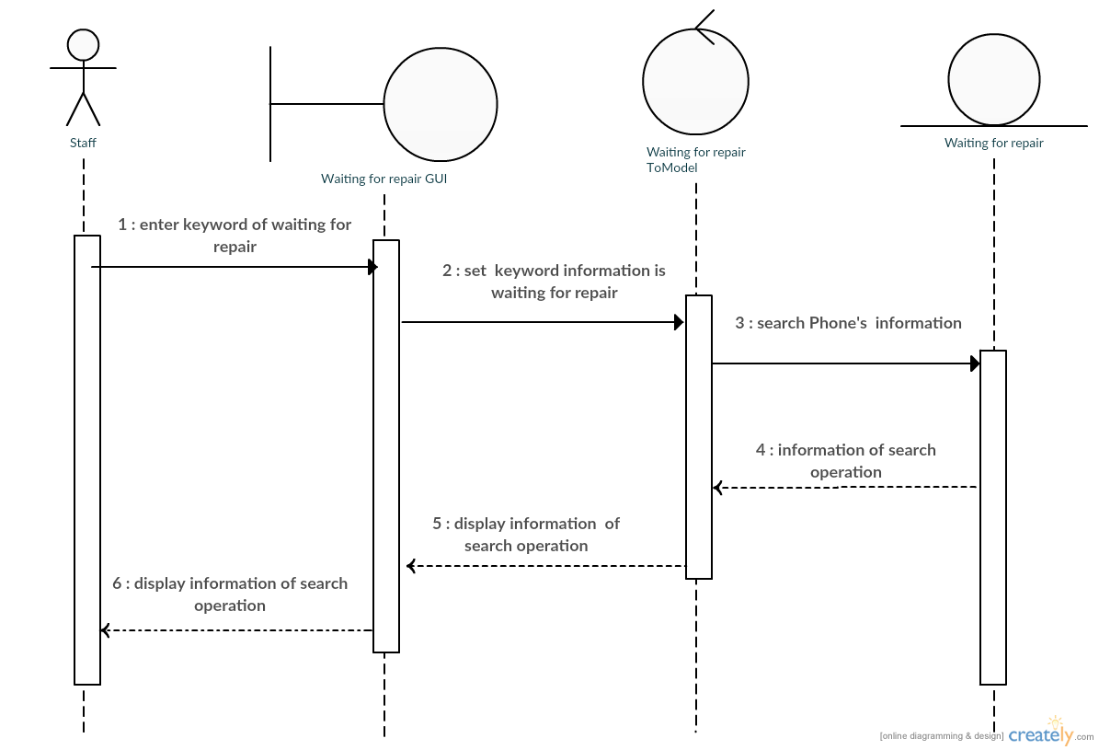

**Sequence Diagram demonstrating operation “repair is done”**

This diagram describes the system scenario of **“UC340: repair is done”**

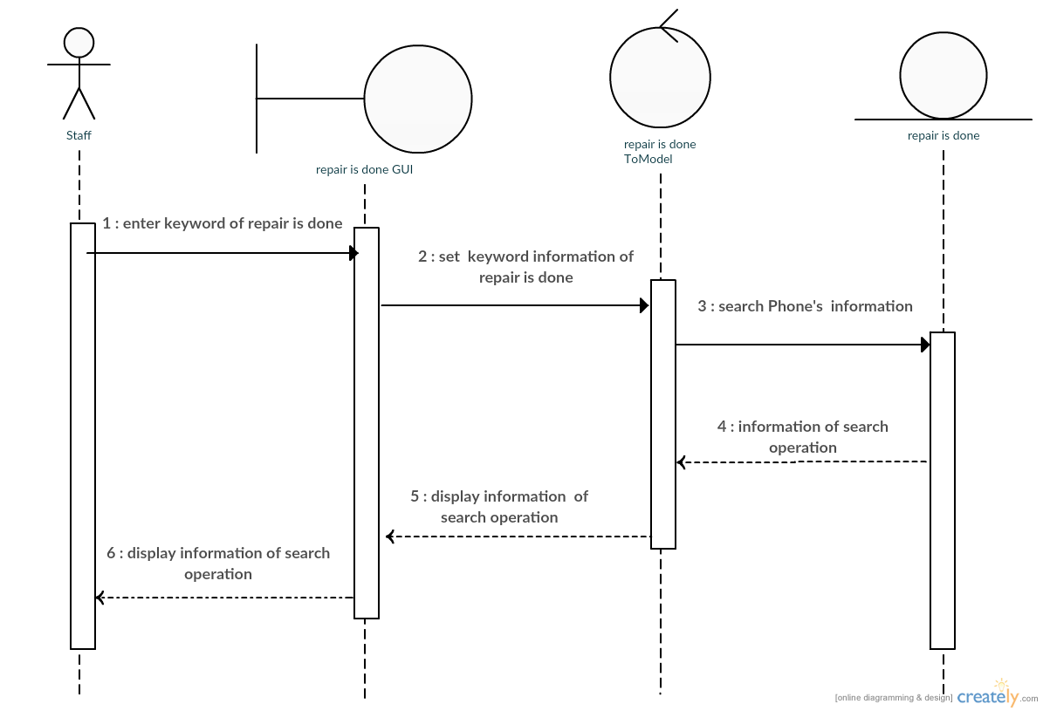

**Sequence Diagram demonstrating operation “Take to repair canter”**

This diagram describes the system scenario of **“UC350: Take to repair canter”**

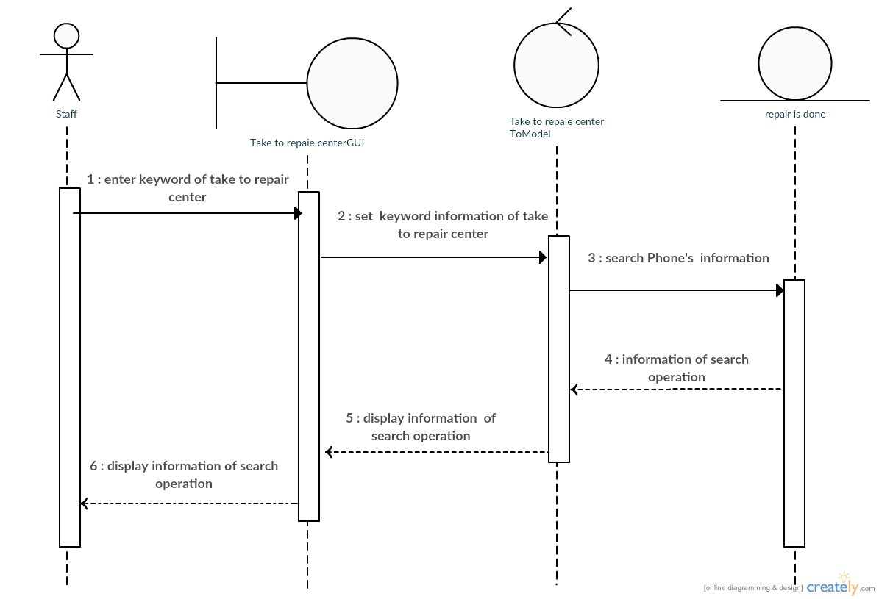

**Sequence Diagram demonstrating operation “Add User, Edit User, Delete User,Add repairman”**

**4. Pesonal**

* 1. **Add User**
* 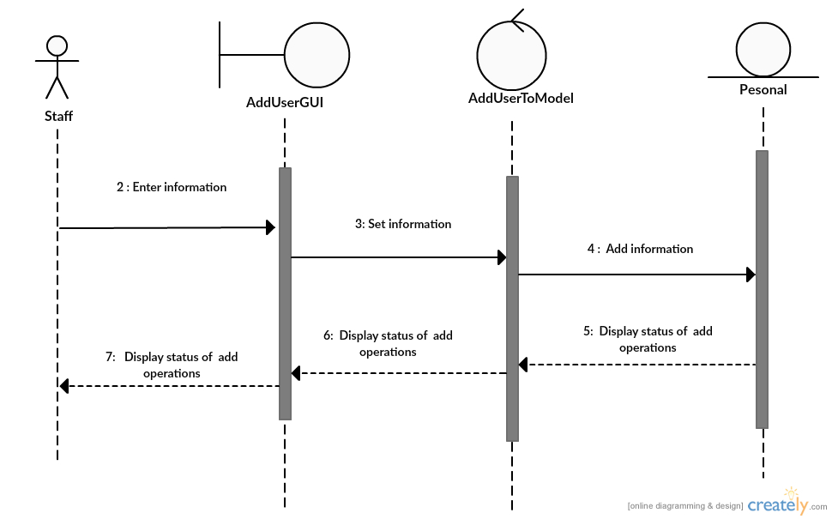This diagram describes the system scenario of “UC410: Add User”
  1. **Edit Repairs**
* This diagram describes the system scenario of “UC420: Edit User”

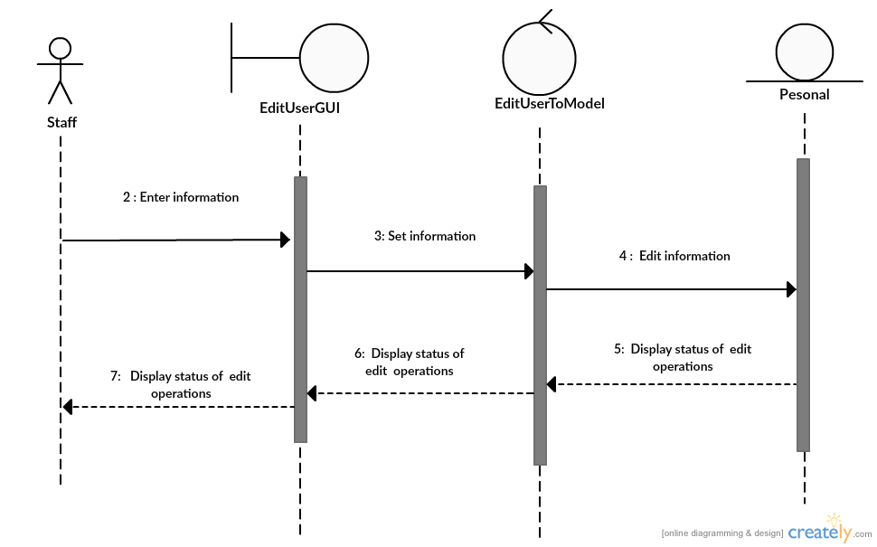

* 1. **Delete User**
* This diagram describes the system scenario of “UC430:Delete User”

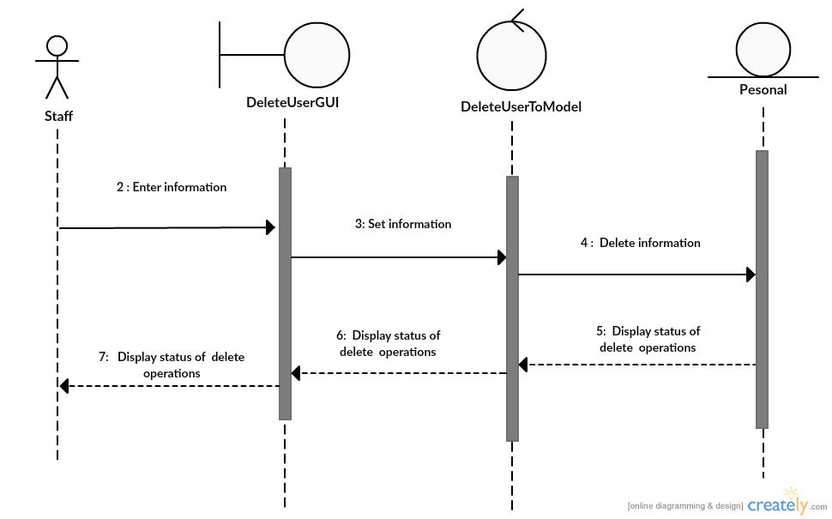

* 1. **Add Repairman**
* This diagram describes the system scenario of “UC440:Bill Repairs”

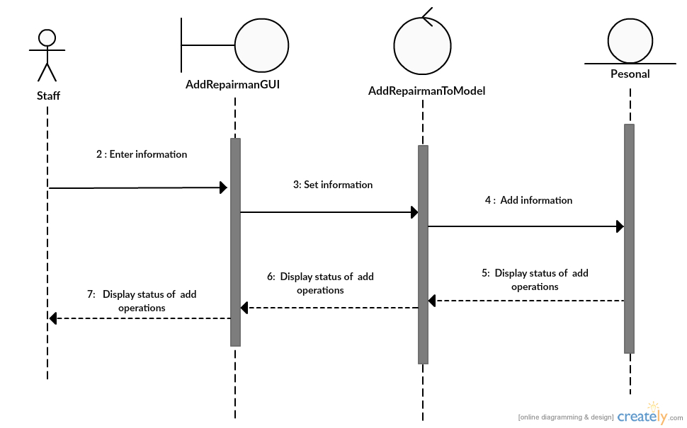

**Sequence Diagram**

**Sequence Diagram demonstrating operation “add Bill”**

This diagram describes the system scenario of **“UC511: Add Bill”**



**Sequence Diagram demonstrating operation “Update Bill”**

This diagram describes the system scenario of **“UC512: Update Bill”**



**Sequence Diagram demonstrating operation “Search Bill”**

This diagram describes the system scenario of **“UC513: Search Bill”**



**Sequence Diagram demonstrating operation “Add About Shop”**

This diagram describes the system scenario of **“UC521: Add About Shop”**



**Sequence Diagram demonstrating operation “Update About Shop”**

This diagram describes the system scenario of **“UC522: Update About Shop”**



**Sequence Diagram demonstrating operation “In come”**

This diagram describes the system scenario of **“UC611: Income”**

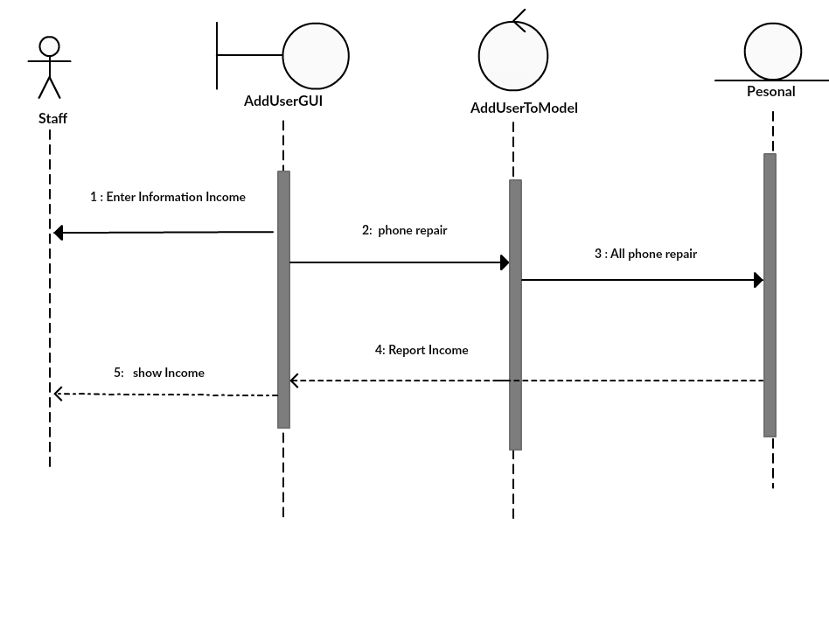

**Sequence Diagram demonstrating operation “Customer’s Info. As Repair”**

This diagram describes the system scenario of **“UC612:Customer’s Info. As Repair ”**

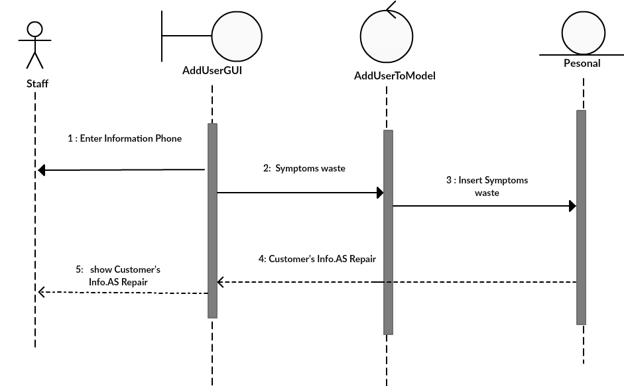

**Sequence Diagram demonstrating operation “Repairman”**

This diagram describes the system scenario of **“UC613: Repairman”**

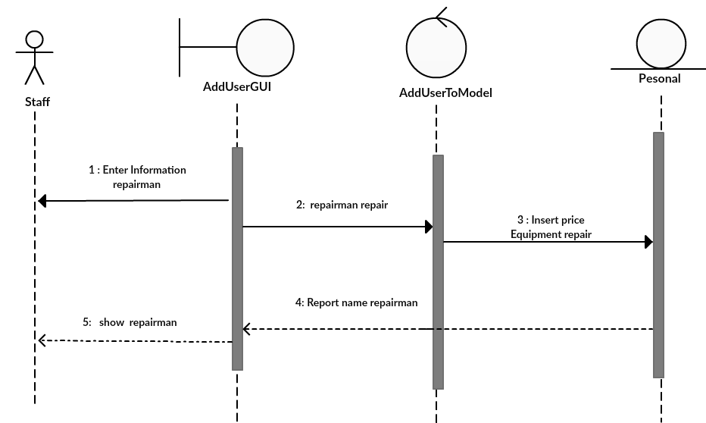

**Sequence Diagram demonstrating operation “expenditure”**

This diagram describes the system scenario of **“UC614: expenditure”**

